Project 2:

Pub/ Sub Model

By: Zhi wen Huang

Weiyang Chen

PHASE1:

In phase1 of this project, we did not use much of other software except for Docker and Python as our application. The UI is really simple for client to open the webpage and type in their python code and that it will send the code to Docker and build it as an image, run the image which will produce the output inside the docker container and the web too. To be more clear, here are some examples of how the UI looks like:

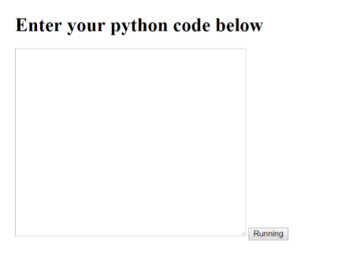

Really simple UI and client can just type the code inside the box and click submit.

After clicking the submit the output will be right below the box showing this:

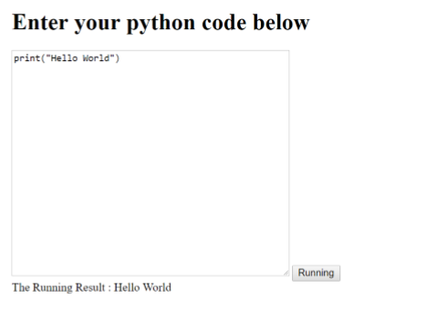

So this is what the client will see when using the application for phase1. What happen back-end, Docker terminal side, is that it will build an image of the python code written inside the message box after the client click the “Running” button.

Here is an example from above:

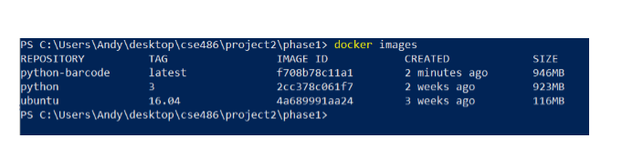

Python-barcode is the name we given for the image. At the same time Docker runs that image when it was created:

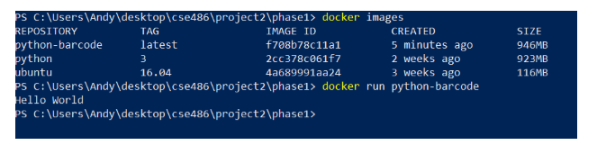

The output is also shown in the terminal.

So we know that after clicking the “Running” button, it builds the image for us and all we have to do is run it using Docker.